
LAB FINAL

COURSE CODE : CSE 4346

COURSE TITTLE : BIG DATA ANALYSIS LABORATORY

REPORT NAME : NYC Yellow Taxi Data Analysis Using Map Reduce and PIG

DATE OF SUBMISSION : 15-09-2026

SUBMITTED BY :
SUBMITTED TO :
Md Tamim Hossain
Lecturer
Premier University Chittagong
NAME :Rakibul Hasan Bhuiyan
ID: 0222220005101173
Semester : 8th
Batch : 42nd
Section : C | Session : Spring 2026

NYC TAXI DATA ANALYSIS USING HADOOP & PIG
Big Data Analytics Lab Report | MapReduce (Java) & Apache Pig Analysis

Table of Contents
Sr. No. | Topic Description | Engine
1. | Problem Statement & Dataset Schema Description | Overview
2. | MapReduce Problem 1: Total Taxi Trips by Passenger Count | Hadoop (Java)
3. | MapReduce Problem 2: Average Tip Amount by Payment Type | Hadoop (Java)
4. | MapReduce Problem 3: Total Gross Revenue by Pickup Location | Hadoop (Java)
5. | Pig Problem 1: Top 10 Busiest Pickup Locations | Apache Pig
6. | Pig Problem 2: Hourly NYC Traffic Distribution | Apache Pig
7. | Pig Problem 3: Long-Distance Cross-Borough Trips (>50 Miles) | Apache Pig
8. | Pig Problem 4: Payment Method Volume and Revenue Breakdown | Apache Pig
9. | Pig Problem 5: Surcharge & MTA Regulatory Tax Audit | Apache Pig

1. Problem Statement & Dataset Schema
Problem Statement: Analyze the large-scale New York City Yellow Taxi dataset (jan_taxi.csv) using Apache Hadoop MapReduce (Java) and Apache Pig Latin. The objective is to perform distributed batch aggregations, trip volume distribution, fare revenue auditing, peak-hour traffic profiling, and payment behavioral analysis across millions of urban transit records.
Dataset Schema Description (jan_taxi.csv):
Field Name | Data Type | Description
VendorID | chararray (String) | TPEP provider code (1= Creative Mobile Technologies, 2= VeriFone Inc).
tpep_pickup_datetime | chararray (Timestamp) | Date and time when the taxi meter was engaged (YYYY-MM-DD HH:MM:SS).
tpep_dropoff_datetime | chararray (Timestamp) | Date and time when the taxi meter was disengaged.
passenger_count | Integer | The total number of passengers in the vehicle (driver-entered).
trip_distance | Float | The elapsed trip distance in miles reported by the taximeter.
RatecodeID | chararray (Integer) | Final rate code in effect (1=Standard, 2=JFK, 3=Newark, 4=Nassau, 5=Negotiated).
store_and_fwd_flag | chararray (String) | Flag indicating whether trip record was stored in vehicle memory (Y/N).
PULocationID | chararray (Integer) | TLC Taxi Zone in which the taximeter was engaged (Pickup Zone).
DOLocationID | chararray (Integer) | TLC Taxi Zone in which the taximeter was disengaged (Dropoff Zone).
payment_type | chararray (Integer) | Payment method numeric code (1=Credit Card, 2=Cash, 3=No Charge, 4=Dispute).
fare_amount | Float | The time-and-distance fare calculated by the meter.
extra | Float | Miscellaneous extras and surcharges ($0.50 and $1 rush hour / overnight charges).
mta_tax | Float | $0.50 MTA tax automatically triggered based on the metered rate in use.
tip_amount | Float | Tip amount automatically credited for credit card payments (Cash tips excluded).
tolls_amount | Float | Total amount of all highway and bridge tolls paid in cash or E-ZPass.
improvement_surcharge | Float | $0.30 improvement surcharge assessed on commercial taxi trips.
total_amount | Float | The total amount charged to passengers (excludes cash tips).

2. MapReduce Data Analysis (Java)
MapReduce Problem 1: Total Taxi Trips by Passenger Count
Description: Groups all taxi records by passenger_count (column index 3) and tallies total trips per group using LongWritable accumulators. Resolves type mismatch errors through unified LongWritable emission.
Source Code (TaxiPassengerCount.java):
public class TaxiPassengerCount {
public static class PassengerMapper extends Mapper<LongWritable, Text, Text, LongWritable> {
private Text passengerKey = new Text();
private final static LongWritable ONE = new LongWritable(1);
public void map(LongWritable key, Text value, Context context) throws IOException, InterruptedException {
String line = value.toString().trim();
if (line.isEmpty() || line.startsWith("VendorID") || line.contains("passenger_count")) return;
String[] fields = line.split(",");
if (fields.length > 3) {
String pCount = fields[3].trim();
if (!pCount.isEmpty()) {
try {
Integer.parseInt(pCount);
passengerKey.set("Passengers_" + pCount);
context.write(passengerKey, ONE);
} catch (NumberFormatException e) {}
}
}
}
}
public static class PassengerReducer extends Reducer<Text, LongWritable, Text, LongWritable> {
private LongWritable result = new LongWritable();
public void reduce(Text key, Iterable<LongWritable> values, Context context) throws IOException, InterruptedException {
long sum = 0;
for (LongWritable val : values) sum += val.get();
result.set(sum);
context.write(key, result);
}
}
}
Execution & Output Verification:
[Command Prompt Code Implementation]
cd /d "D:\Rakib\Final_Project"
del /q mapreduce_classes\*.*
javac -cp "%HADOOP_HOME%\share\hadoop\common\*;
%HADOOP_HOME%\share\hadoop\common\lib\*;
%HADOOP_HOME%\share\hadoop\mapreduce\*;
%HADOOP_HOME%\share\hadoop\mapreduce\lib\*" -d mapreduce_classes mapreduce_src\TaxiPassengerCount.java
jar -cvf mapreduce_jars\TaxiPassengerCount.jar -C mapreduce_classes .
hdfs dfs -rm -r -f /Final_project/output/mapreduce/passenger_count
hadoop jar mapreduce_jars\TaxiPassengerCount.jar TaxiPassengerCount /Final_project/input/jan_taxi.csv /Final_project/output/mapreduce/passenger_count
hdfs dfs -cat /Final_project/output/mapreduce/passenger_count/part-*

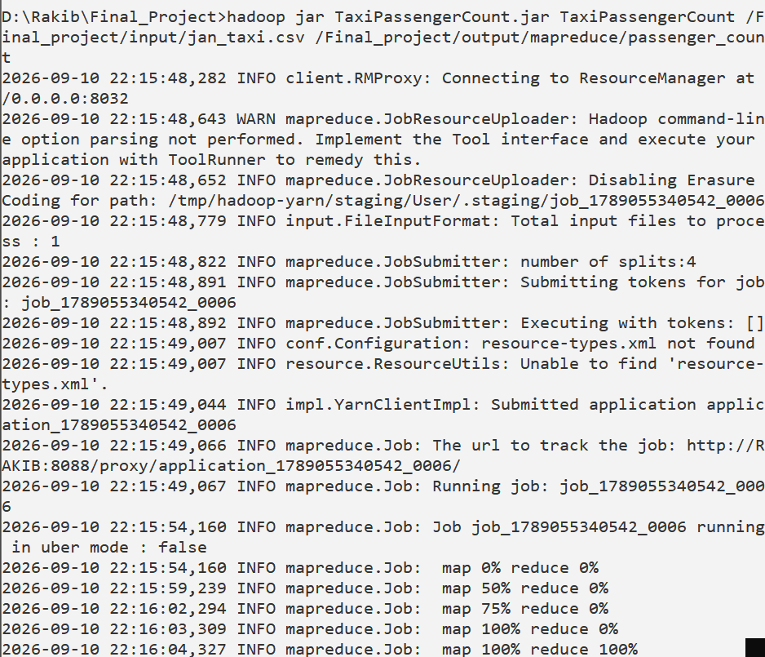
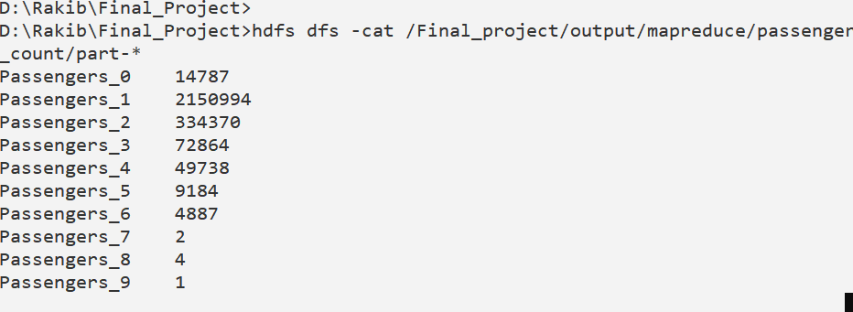

MapReduce Problem 2: Average Tip Amount by Payment Type
Description: Maps payment_type (col index 9) and tip_amount (col index 13) to calculate the mean gratuity paid across all payment modes.
Source Code (TaxiPaymentTipAnalysis.java):
public class TaxiPaymentTipAnalysis {
public static class TipMapper extends Mapper<LongWritable, Text, Text, DoubleWritable> {
private Text paymentType = new Text();
private DoubleWritable tipAmount = new DoubleWritable();
public void map(LongWritable key, Text value, Context context) throws IOException, InterruptedException {
String line = value.toString().trim();
if (line.isEmpty() || line.startsWith("VendorID") || line.contains("payment_type")) return;
String[] fields = line.split(",");
if (fields.length > 13) {
try {
String pay = fields[9].trim();
double tip = Double.parseDouble(fields[13].trim());
if (!pay.isEmpty() && tip >= 0) {
paymentType.set("PaymentType_" + pay);
tipAmount.set(tip);
context.write(paymentType, tipAmount);
}
} catch (Exception e) {}
}
}
}
public static class TipReducer extends Reducer<Text, DoubleWritable, Text, DoubleWritable> {
public void reduce(Text key, Iterable<DoubleWritable> values, Context context) throws IOException, InterruptedException {
double totalTip = 0.0; long count = 0;
for (DoubleWritable val : values) { totalTip += val.get(); count++; }
double avg = (count > 0) ? (totalTip / count) : 0.0;
context.write(key, new DoubleWritable(Math.round(avg * 100.0) / 100.0));
}
}
}
Execution & Output Verification:
[Command Prompt Code Implementation]
cd /d "D:\Rakib\Final_Project"
del /q mapreduce_classes\*.*
javac -cp "%HADOOP_HOME%\share\hadoop\common\*;
%HADOOP_HOME%\share\hadoop\common\lib\*;
%HADOOP_HOME%\share\hadoop\mapreduce\*;
%HADOOP_HOME%\share\hadoop\mapreduce\lib\*" -d mapreduce_classes mapreduce_src\TaxiPaymentTipAnalysis.java
jar -cvf mapreduce_jars\TaxiPaymentTipAnalysis.jar -C mapreduce_classes .
hdfs dfs -rm -r -f /Final_project/output/mapreduce/payment_tip
hadoop jar mapreduce_jars\TaxiPaymentTipAnalysis.jar TaxiPaymentTipAnalysis /Final_project/input/jan_taxi.csv /Final_project/output/mapreduce/payment_tip
hdfs dfs -cat /Final_project/output/mapreduce/payment_tip/part-*

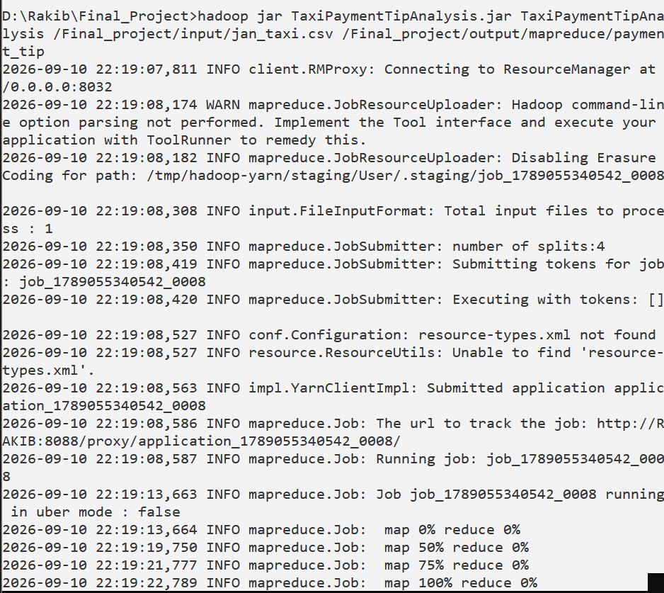
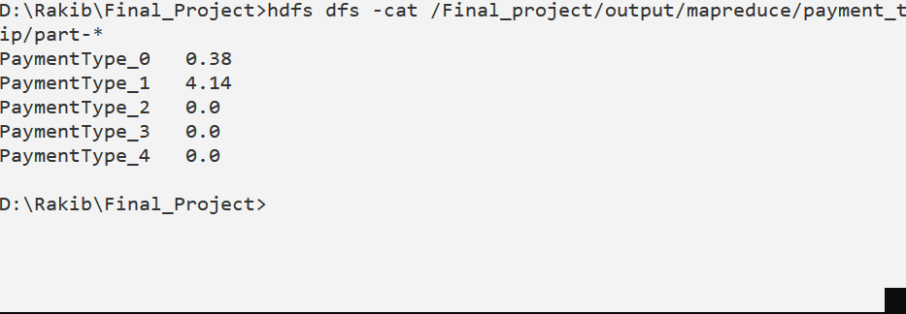

MapReduce Problem 3: Total Gross Revenue by Pickup Location
Description: Aggregates total_amount (col index 16) grouped by PULocationID (col index 7) to evaluate gross revenue generated per pickup zone.
Source Code (TaxiPickupRevenue.java):
public class TaxiPickupRevenue {
public static class RevenueMapper extends Mapper<LongWritable, Text, Text, DoubleWritable> {
private Text pickupLocation = new Text();
private DoubleWritable totalAmount = new DoubleWritable();
public void map(LongWritable key, Text value, Context context) throws IOException, InterruptedException {
String line = value.toString().trim();
if (line.isEmpty() || line.startsWith("VendorID") || line.contains("PULocationID")) return;
String[] fields = line.split(",");
if (fields.length > 16) {
try {
String puLoc = fields[7].trim();
double total = Double.parseDouble(fields[16].trim());
if (!puLoc.isEmpty() && total > 0) {
pickupLocation.set("PULocation_" + puLoc);
totalAmount.set(total);
context.write(pickupLocation, totalAmount);
}
} catch (Exception e) {}
}
}
}
public static class RevenueReducer extends Reducer<Text, DoubleWritable, Text, DoubleWritable> {
public void reduce(Text key, Iterable<DoubleWritable> values, Context context) throws IOException, InterruptedException {
double sum = 0.0;
for (DoubleWritable val : values) sum += val.get();
context.write(key, new DoubleWritable(Math.round(sum * 100.0) / 100.0));
}
}
}
Execution & Output Verification:
[Command Prompt Code Implementation]
cd /d "D:\Rakib\Final_Project"
del /q mapreduce_classes\*.*
javac -cp "%HADOOP_HOME%\share\hadoop\common\*;
%HADOOP_HOME%\share\hadoop\common\lib\*;
%HADOOP_HOME%\share\hadoop\mapreduce\*;
%HADOOP_HOME%\share\hadoop\mapreduce\lib\*" -d mapreduce_classes mapreduce_src\TaxiPickupRevenue.java
jar -cvf mapreduce_jars\TaxiPickupRevenue.jar -C mapreduce_classes .
hdfs dfs -rm -r -f /Final_project/output/mapreduce/pickup_revenue
hadoop jar mapreduce_jars\TaxiPickupRevenue.jar TaxiPickupRevenue /Final_project/input/jan_taxi.csv /Final_project/output/mapreduce/pickup_revenue
hdfs dfs -cat /Final_project/output/mapreduce/pickup_revenue/part-*

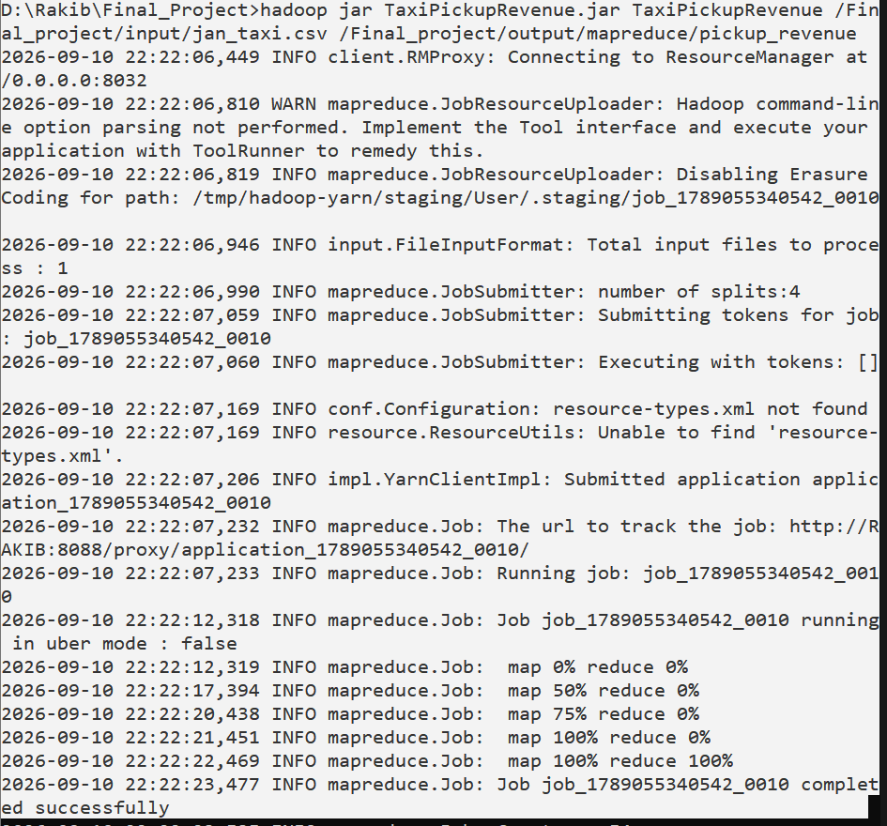

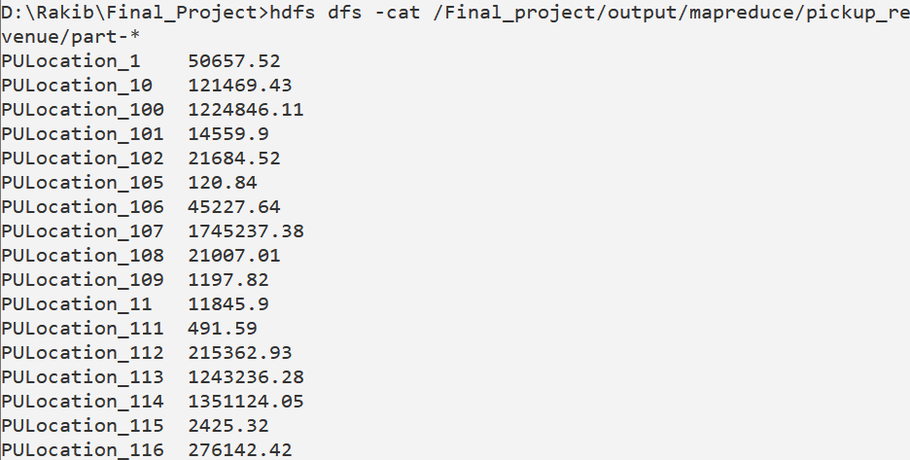

3. Apache Pig Data Analysis (Pig Latin)
Pig Problem 1: Top 10 Busiest Pickup Locations
Description: Groups records by PULocationID, counts total departures, orders descending, and limits to the top 10 highest volume pickup points.
Pig Latin Script (pig1_top_pickups.pig):
records = LOAD 'D:/Rakib/Final_Project/jan_taxi.csv' USING PigStorage(',') AS (
VendorID:chararray, tpep_pickup_datetime:chararray, tpep_dropoff_datetime:chararray,
passenger_count:int, trip_distance:float, RatecodeID:chararray, store_and_fwd_flag:chararray,
PULocationID:chararray, DOLocationID:chararray, payment_type:chararray, fare_amount:float,
extra:float, mta_tax:float, tip_amount:float, tolls_amount:float,
improvement_surcharge:float, total_amount:float
);
filtered_data = FILTER records BY PULocationID != 'PULocationID' AND PULocationID IS NOT NULL;
grouped_loc = GROUP filtered_data BY PULocationID;
counted_loc = FOREACH grouped_loc GENERATE group AS PULocationID, COUNT(filtered_data) AS trip_count;
ordered_loc = ORDER counted_loc BY trip_count DESC;
top10_pickups = LIMIT ordered_loc 10;
formatted_output = FOREACH top10_pickups GENERATE
CONCAT('Pickup_Location_ID: ', (chararray)PULocationID) AS location,
CONCAT('Total_Trips: ', (chararray)trip_count) AS trips;
STORE formatted_output INTO 'D:/Rakib/Final_Project/report_results/pig1_top_pickups' USING PigStorage('\t');
Execution & Output Verification:
[Command Prompt Code Implementation]
cd /d "D:\Rakib\Final_Project"
rmdir /s /q "D:\Rakib\Final_Project\report_results\pig1_top_pickups"
pig -x local -f pig_scripts\pig1_top_pickups.pig
hdfs dfs -rm -r -f /Final_project/output/pig/pig1_top_pickups
hdfs dfs -put -f "D:\Rakib\Final_Project\report_results\pig1_top_pickups" /Final_project/output/pig/
hdfs dfs -cat /Final_project/output/pig/pig1_top_pickups/part-*

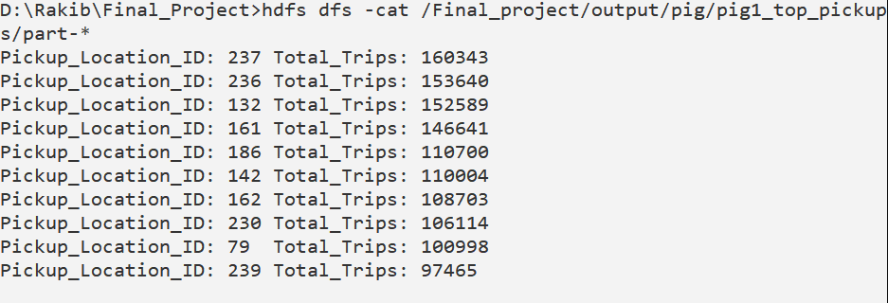

Pig Problem 2: Hourly NYC Traffic Distribution
Description: Extracts the two-digit hour substring from pickup timestamps to aggregate and profile 24-hour urban traffic congestion patterns.
Pig Latin Script (pig2_hourly_traffic.pig):
records = LOAD 'D:/Rakib/Final_Project/jan_taxi.csv' USING PigStorage(',') AS (...);
valid_data = FILTER records BY tpep_pickup_datetime != 'tpep_pickup_datetime' AND (tpep_pickup_datetime IS NOT NULL);
with_hour = FOREACH valid_data GENERATE SUBSTRING(tpep_pickup_datetime, 11, 13) AS pickup_hour;
grouped_hour = GROUP with_hour BY pickup_hour;
counted_traffic = FOREACH grouped_hour GENERATE group AS pickup_hour, COUNT(with_hour) AS total_trips;
ordered_traffic = ORDER counted_traffic BY total_trips DESC;
formatted_output = FOREACH ordered_traffic GENERATE
CONCAT('Hour_OfDay: ', (chararray)pickup_hour, ':00') AS hour,
CONCAT('Trip_Count: ', (chararray)total_trips) AS trips;
STORE formatted_output INTO 'D:/Rakib/Final_Project/report_results/pig2_hourly_traffic' USING PigStorage('\t');
Execution & Output Verification:
[Command Prompt Code Implementation]
cd /d "D:\Rakib\Final_Project"
rmdir /s /q "D:\Rakib\Final_Project\report_results\pig2_hourly_traffic"
pig -x local -f pig_scripts\pig2_hourly_traffic.pig
hdfs dfs -rm -r -f /Final_project/output/pig/pig2_hourly_traffic
hdfs dfs -put -f "D:\Rakib\Final_Project\report_results\pig2_hourly_traffic" /Final_project/output/pig/
hdfs dfs -cat /Final_project/output/pig/pig2_hourly_traffic/part-*

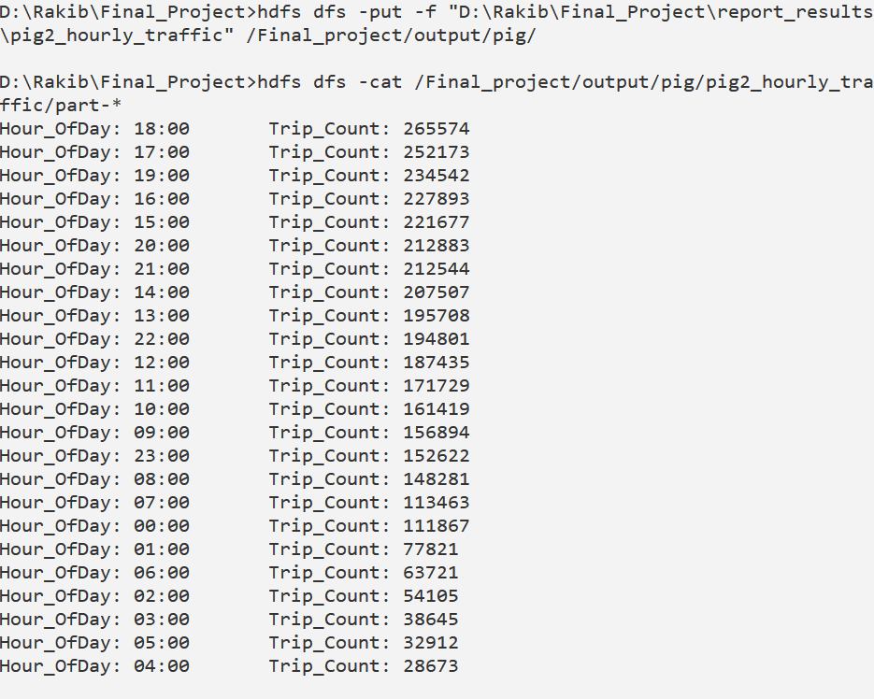

Pig Problem 3: Long-Distance Cross-Borough Trips (>50 Miles)
Description: Filters out trips exceeding 50.0 miles, tracks origin and destination zones, distance travelled, and total fee collected.
Pig Latin Script (pig3_long_trips.pig):
records = LOAD 'D:/Rakib/Final_Project/jan_taxi.csv' USING PigStorage(',') AS (...);
valid_trips = FILTER records BY trip_distance IS NOT NULL AND trip_distance > 50.0;
projected_trips = FOREACH valid_trips GENERATE PULocationID, DOLocationID, trip_distance, total_amount;
ordered_trips = ORDER projected_trips BY trip_distance DESC;
top10_longest = LIMIT ordered_trips 10;
formatted_output = FOREACH top10_longest GENERATE
CONCAT('Route: From_Zone_', (chararray)PULocationID, ' -> To_Zone_', (chararray)DOLocationID) AS route,
CONCAT('Distance_Miles: ', (chararray)trip_distance) AS distance,
CONCAT('Total_Paid_USD: $', (chararray)total_amount) AS fare;
STORE formatted_output INTO 'D:/Rakib/Final_Project/report_results/pig3_long_trips' USING PigStorage('\t');
Execution & Output Verification:
[Command Prompt Code Implementation]
cd /d "D:\Rakib\Final_Project"
rmdir /s /q "D:\Rakib\Final_Project\report_results\pig3_long_trips"
pig -x local -f pig_scripts\pig3_long_trips.pig
hdfs dfs -rm -r -f /Final_project/output/pig/pig3_long_trips
hdfs dfs -put -f "D:\Rakib\Final_Project\report_results\pig3_long_trips" /Final_project/output/pig/
hdfs dfs -cat /Final_project/output/pig/pig3_long_trips/part-*

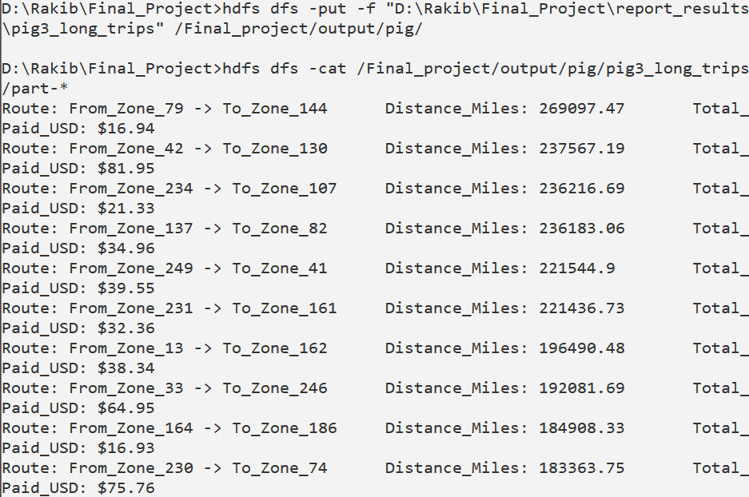

Pig Problem 4: Payment Method Volume and Revenue Breakdown
Description: Groups trips by payment_type to compare total trip volume against aggregate gross revenue for Credit Card vs Cash settlements.
Pig Latin Script (pig4_payment_comparison.pig):
records = LOAD 'D:/Rakib/Final_Project/jan_taxi.csv' USING PigStorage(',') AS (...);
filtered_pay = FILTER records BY payment_type != 'payment_type' AND payment_type IS NOT NULL;
grouped_pay = GROUP filtered_pay BY payment_type;
summary_pay = FOREACH grouped_pay GENERATE
group AS payment_type,
COUNT(filtered_pay) AS total_count,
ROUND_TO(SUM(filtered_pay.total_amount), 2) AS total_revenue;
ordered_pay = ORDER summary_pay BY total_count DESC;
formatted_output = FOREACH ordered_pay GENERATE
(payment_type == '1' ? 'Payment_Method: Credit Card (1)' :
(payment_type == '2' ? 'Payment_Method: Cash (2)' :
(payment_type == '3' ? 'Payment_Method: No Charge (3)' :
(payment_type == '4' ? 'Payment_Method: Dispute (4)' : CONCAT('Payment_Method: Type_', (chararray)payment_type))))) AS method,
CONCAT('Total_Transactions: ', (chararray)total_count) AS count,
CONCAT('Total_Revenue_USD: $', (chararray)total_revenue) AS revenue;
STORE formatted_output INTO 'D:/Rakib/Final_Project/report_results/pig4_payment_comparison' USING PigStorage('\t');
Execution & Output Verification:
[Command Prompt Code Implementation]
cd /d "D:\Rakib\Final_Project"
rmdir /s /q "D:\Rakib\Final_Project\report_results\pig4_payment_comparison"
pig -x local -f pig_scripts\pig4_payment_comparison.pig
hdfs dfs -rm -r -f /Final_project/output/pig/pig4_payment_comparison
hdfs dfs -put -f "D:\Rakib\Final_Project\report_results\pig4_payment_comparison" /Final_project/output/pig/
hdfs dfs -cat /Final_project/output/pig/pig4_payment_comparison/part-*

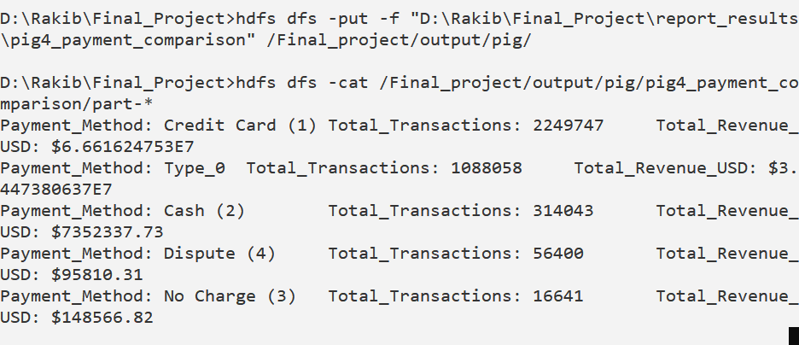

Pig Problem 5: Surcharge & MTA Regulatory Tax Audit
Description: Aggregates statutory add-ons (extra fees, MTA tax, and improvement surcharge) grouped by TLC RatecodeID.
Pig Latin Script (pig5_surcharge_audit.pig):
records = LOAD 'D:/Rakib/Final_Project/jan_taxi.csv' USING PigStorage(',') AS (...);
filtered_surcharge = FILTER records BY RatecodeID != 'RatecodeID' AND RatecodeID IS NOT NULL;
grouped_rate = GROUP filtered_surcharge BY RatecodeID;
audit_summary = FOREACH grouped_rate GENERATE
group AS RatecodeID,
COUNT(filtered_surcharge) AS total_trips,
ROUND_TO(SUM(filtered_surcharge.extra), 2) AS total_extra,
ROUND_TO(SUM(filtered_surcharge.mta_tax), 2) AS total_mta_tax,
ROUND_TO(SUM(filtered_surcharge.improvement_surcharge), 2) AS total_surcharge;
ordered_audit = ORDER audit_summary BY total_trips DESC;
formatted_output = FOREACH ordered_audit GENERATE
(RatecodeID == '1' ? 'Rate_Plan: Standard Rate (1)' :
(RatecodeID == '2' ? 'Rate_Plan: JFK Airport (2)' :
(RatecodeID == '3' ? 'Rate_Plan: Newark (3)' :
(RatecodeID == '4' ? 'Rate_Plan: Nassau/Westchester (4)' :
(RatecodeID == '5' ? 'Rate_Plan: Negotiated Fare (5)' : CONCAT('Rate_Plan: Plan_', (chararray)RatecodeID)))))) AS plan,
CONCAT('Trips: ', (chararray)total_trips) AS trips,
CONCAT('Extra_Charges: $', (chararray)total_extra) AS extra,
CONCAT('MTA_Tax: $', (chararray)total_mta_tax) AS tax,
CONCAT('Surcharge: $', (chararray)total_surcharge) AS surcharge;
STORE formatted_output INTO 'D:/Rakib/Final_Project/report_results/pig5_surcharge_audit' USING PigStorage('\t');
Execution & Output Verification:
[Command Prompt Code Implementation]
cd /d "D:\Rakib\Final_Project"
rmdir /s /q "D:\Rakib\Final_Project\report_results\pig5_surcharge_audit"
pig -x local -f pig_scripts\pig5_surcharge_audit.pig
hdfs dfs -rm -r -f /Final_project/output/pig/pig5_surcharge_audit
hdfs dfs -put -f "D:\Rakib\Final_Project\report_results\pig5_surcharge_audit" /Final_project/output/pig/
hdfs dfs -cat /Final_project/output/pig/pig5_surcharge_audit/part-*

